Mobile Application Development Lab Session Week 9A
Create Login and Registration App using Firebase Authentication

Overview of Firebase
As discussed in the lecture, Firebase is a cloud-based app development environment and has many features, including databases, that work well with Android apps. Today's lab demonstrates how to use a cloud-based, Realtime database with your app. It comprises three parts, so go through the guide below to do the exercise. As usual, we will be around to support you.

- Open new project and select Empty Views Activity template. Call the new project as LoginAndRegisterAuth

- Go to Tools and click on Firebase, and Authentication option

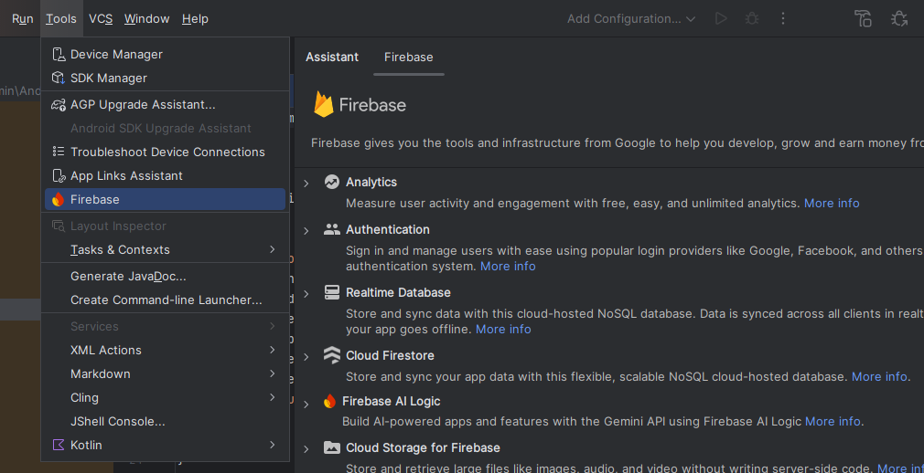
Select Authentication on the assistant tab and then select Authenticate using Google.
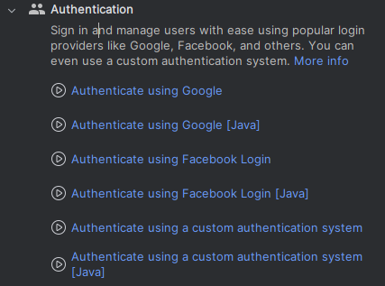

Select Connect to Firebase.
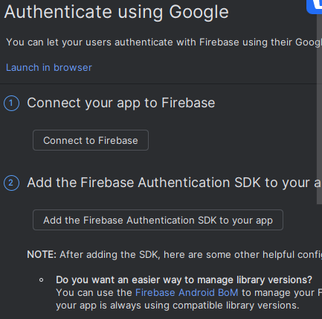
This will open the Firebase Console on your Browser.

Step 4: Create new app in Firebase
Select Get started with a Firebase project.

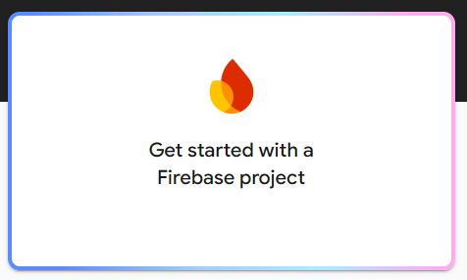
Write a name for your project:

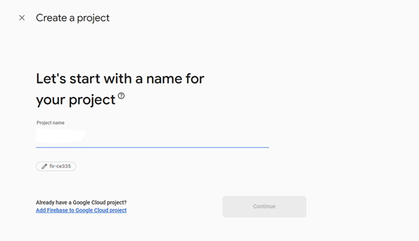
After selecting Connect, it will show a screen where it shows "Your Android Studio project is connected to your Firebase Android app".
Now you can select option 2 to add the Firebase Authentication SDK to your app

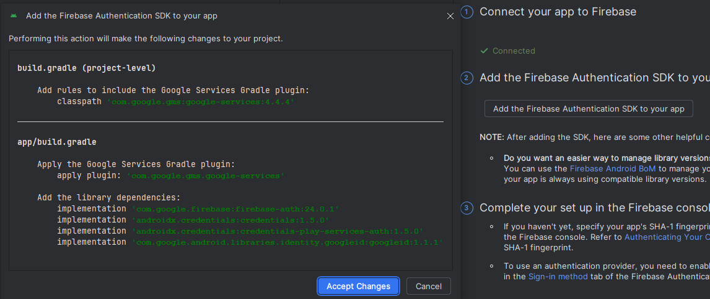

- Open activity_main.xml, and add the following code to it
<?xml version="1.0" encoding="utf-8"?>
<LinearLayout
xmlns:android="http://schemas.android.com/apk/res/android"
xmlns:app="http://schemas.android.com/apk/res-auto"
xmlns:tools="http://schemas.android.com/tools"
android:id="@+id/main"
android:layout_width="match_parent"
android:layout_height="match_parent"
android:gravity="center"
android:padding="32dp"
android:orientation="vertical"
tools:context=".LoginActivity">
<!-- TextView for heading -->
<TextView
android:layout_width="wrap_content"
android:layout_height="wrap_content"
android:text="Login"
android:textSize="32sp"
android:layout_margin="32dp"
android:textStyle="bold"
/>
<!-- Edit text for email -->
<EditText
android:id="@+id/email_edittext"
android:layout_width="match_parent"
android:layout_height="48dp"
android:hint="Enter your Email" />
<!-- Edit text for password -->
<EditText
android:id="@+id/password_edittext"
android:layout_width="match_parent"
android:layout_height="48dp"
android:hint="Enter your Password"
android:inputType="textPassword" />
<!-- Button for register with text "Register" -->
<Button
android:id="@+id/register_button"
android:layout_width="match_parent"
android:layout_height="wrap_content"
android:text="Register" />
<Button
android:id="@+id/login_button"
android:layout_width="match_parent"
android:layout_height="wrap_content"
android:text="Login" />
</LinearLayout>

- Open MainActivity.java and add the following code to it.

import android.os.Bundle;
import android.content.Intent;
import android.os.Bundle;
import android.view.View;
import android.widget.Button;
import androidx.appcompat.app.AppCompatActivity;
public class MainActivity extends AppCompatActivity {
@Override
protected void onCreate(Bundle savedInstanceState) {
super.onCreate(savedInstanceState);
setContentView(R.layout.activity_main);
Button register = findViewById(R.id.register);
Button login = findViewById(R.id.login);
register.setOnClickListener(new View.OnClickListener() {
@Override
public void onClick(View v) {
startActivity(new Intent(MainActivity.this, RegisterActivity.class));
}
});
login.setOnClickListener(new View.OnClickListener() {
@Override
public void onClick(View v) {
startActivity(new Intent(MainActivity.this, LoginActivity.class));
}
});
}
}

- Create activity_login.xml file and add the following code to it.
<?xml version="1.0" encoding="utf-8"?>
<LinearLayout
xmlns:android="http://schemas.android.com/apk/res/android"
xmlns:app="http://schemas.android.com/apk/res-auto"
xmlns:tools="http://schemas.android.com/tools"
android:id="@+id/main"
android:layout_width="match_parent"
android:layout_height="match_parent"
android:gravity="center"
android:padding="32dp"
android:orientation="vertical"
tools:context=".LoginActivity">
<!-- TextView for heading -->
<TextView
android:layout_width="wrap_content"
android:layout_height="wrap_content"
android:text="Login"
android:textSize="32sp"
android:layout_margin="32dp"
android:textStyle="bold"
/>
<!-- Edit text for email -->
<EditText
android:id="@+id/email_edittext"
android:layout_width="match_parent"
android:layout_height="48dp"
android:hint="Enter your Email" />
<!-- Edit text for password -->
<EditText
android:id="@+id/password_edittext"
android:layout_width="match_parent"
android:layout_height="48dp"
android:hint="Enter your Password"
android:inputType="textPassword" />
<!-- Button for register with text "Register" -->
<Button
android:id="@+id/login_button"
android:layout_width="match_parent"
android:layout_height="wrap_content"
android:text="Login" />
</LinearLayout>

- Create LoginActivity.java file and add the following code to it.
import android.content.Intent;
import android.os.Bundle;
import android.widget.Button;
import android.widget.EditText;
import android.widget.Toast;
import androidx.annotation.NonNull;
import androidx.appcompat.app.AppCompatActivity;
import com.google.firebase.auth.FirebaseAuth;
import com.google.firebase.auth.AuthResult;
import com.google.android.gms.tasks.OnCompleteListener;
import com.google.android.gms.tasks.Task;
import java.util.Calendar;
public class LoginActivity extends AppCompatActivity {
private EditText emailTextView, passwordTextView;
private Button button;
private FirebaseAuth auth;
@Override
protected void onCreate(Bundle savedInstanceState) {
super.onCreate(savedInstanceState);
setContentView(R.layout.activity_login);
// Initialize FirebaseAuth instance
auth = FirebaseAuth.getInstance();
emailTextView = findViewById(R.id.email_edittext);
passwordTextView = findViewById(R.id.password_edittext);
button = findViewById(R.id.login_button);
button.setOnClickListener(v -> loginUserAccount());
}
private void loginUserAccount() {
String email = emailTextView.getText().toString().trim();
String password = passwordTextView.getText().toString().trim();
// Validate input
if (email.isEmpty() || password.isEmpty()) {
Toast.makeText(this, "Please enter credentials", Toast.LENGTH_LONG).show();
return;
}
// Login existing user
auth.signInWithEmailAndPassword(email, password)
.addOnCompleteListener(this, new OnCompleteListener<AuthResult>() {
@Override
public void onComplete(@NonNull Task<AuthResult> task) {
if (task.isSuccessful()) {
// Login successful
Toast.makeText(LoginActivity.this, "Login successful!!", Toast.LENGTH_LONG).show();
startActivity(new Intent(LoginActivity.this, MainActivity.class));
finish();
} else {
// Login failed
Toast.makeText(LoginActivity.this, "Login failed!!", Toast.LENGTH_LONG).show();
}
}
});
}
}

- Create activity_register.xml file and add the following code to it.
<?xml version="1.0" encoding="utf-8"?>
<LinearLayout
xmlns:android="http://schemas.android.com/apk/res/android"
xmlns:tools="http://schemas.android.com/tools"
android:id="@+id/main"
android:layout_width="match_parent"
android:layout_height="match_parent"
android:gravity="center"
android:padding="32dp"
android:orientation="vertical"
tools:context=".RegisterActivity">
<!-- TextView for heading -->
<TextView
android:layout_width="wrap_content"
android:layout_height="wrap_content"
android:text="Register"
android:textSize="32sp"
android:layout_margin="32dp"
android:textStyle="bold"
/>
<!-- Edit text for email -->
<EditText
android:id="@+id/email_edittext"
android:layout_width="match_parent"
android:layout_height="48dp"
android:hint="Enter your Email" />
<!-- Edit text for password -->
<EditText
android:id="@+id/password_edittext"
android:layout_width="match_parent"
android:layout_height="48dp"
android:hint="Enter your Password"
android:inputType="textPassword" />
<!-- Button for register with text "Register" -->
<Button
android:id="@+id/register_button"
android:layout_width="match_parent"
android:layout_height="48dp"
android:text="Register" />
</LinearLayout>

- Create RegisterActivity.java file and the following code to it.
import android.content.Intent;
import android.os.Bundle;
import android.view.View;
import android.widget.Button;
import android.widget.EditText;
import android.widget.Toast;
import androidx.annotation.NonNull;
import androidx.appcompat.app.AppCompatActivity;
import com.google.firebase.auth.FirebaseAuth;
import com.google.firebase.auth.AuthResult;
import com.google.android.gms.tasks.OnCompleteListener;
import com.google.android.gms.tasks.Task;
public class RegisterActivity extends AppCompatActivity {
private EditText emailTextView, passwordTextView;
private Button button;
private FirebaseAuth auth;
@Override
protected void onCreate(Bundle savedInstanceState) {
super.onCreate(savedInstanceState);
setContentView(R.layout.activity_register);
// Initialize FirebaseAuth instance
auth = FirebaseAuth.getInstance();
emailTextView = findViewById(R.id.email_edittext);
passwordTextView = findViewById(R.id.password_edittext);
button = findViewById(R.id.register_button);
button.setOnClickListener(new View.OnClickListener() {
@Override
public void onClick(View v) {
registerNewUser();
}
});
}
private void registerNewUser() {
// Get values from input fields
String email = emailTextView.getText().toString().trim();
String password = passwordTextView.getText().toString().trim();
// Validate input
if (email.isEmpty() || password.isEmpty()) {
Toast.makeText(this, "Please enter credentials", Toast.LENGTH_LONG).show();
return;
}

// Register new user with Firebase
auth.createUserWithEmailAndPassword(email, password)
.addOnCompleteListener(this, new OnCompleteListener<AuthResult>() {
@Override
public void onComplete(@NonNull Task<AuthResult> task) {
if (task.isSuccessful()) {
Toast.makeText(RegisterActivity.this, "Registration successful!", Toast.LENGTH_LONG).show();
// Navigate to MainActivity
startActivity(new Intent(RegisterActivity.this, MainActivity.class));
finish();
} else {
// Registration failed
Toast.makeText(RegisterActivity.this, "Registration failed! Please try again later", Toast.LENGTH_LONG).show();
}
}
});
}
}

- Open AndroidManifest.xml and add the following line before <application tag
<uses-permission android:name="android.permission.INTERNET"/>

Mobile Application Development Lab Session Week 9B

Create Login and Registration App using Realtime Database Firebase
- Open new project and select Empty Views Activity template. Call the new project as LoginAndRegisterRealTimeDB

Go to Tools and click on Firebase, and select Realtime Database option


Select Realtime Database on the assistant tab and then select Get started with Realtime Database option

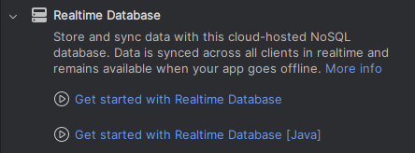

Select Connect to Firebase
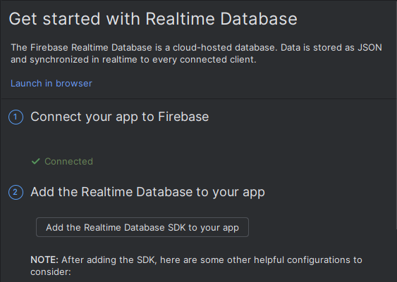

This will open the Firebase Console on your Browser.
Create new app in Firebase
Select Get started with a Firebase project.


Write a name for your project:


After selecting Connect, it will show a screen where it shows "Your Android Studio project is connected to your Firebase Android app".
Now you can select option 2 to add the Realtime Database SDK to your app

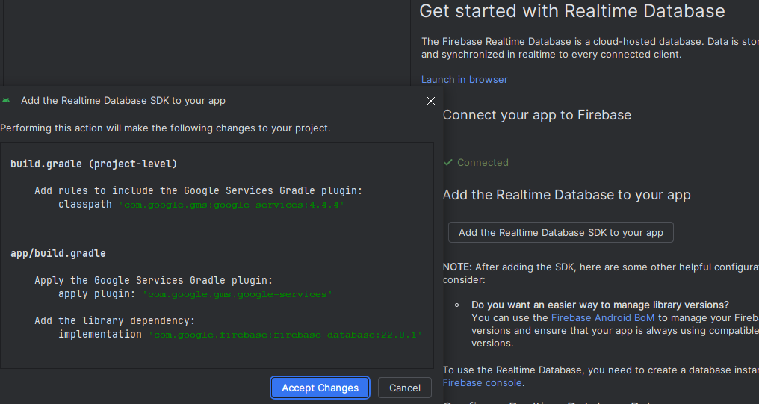
Then click Accept Changes button

- Open activity_main.xml file and add the following code to it.

<?xml version="1.0" encoding="utf-8"?>
<RelativeLayout xmlns:android="http://schemas.android.com/apk/res/android"
xmlns:app="http://schemas.android.com/apk/res-auto"
xmlns:tools="http://schemas.android.com/tools"
android:layout_width="match_parent"
android:layout_height="match_parent"
tools:context=".MainActivity"
android:background="@drawable/background_main"
app:layout_goneMarginBottom="10dp">
<include layout="@layout/toolbar"
android:id="@+id/tool_main"/>
<LinearLayout
android:layout_width="match_parent"
android:layout_height="match_parent"
android:gravity="center"
android:orientation="vertical"
tools:ignore="MissingConstraints" >
<TextView
android:layout_width="match_parent"
android:layout_height="wrap_content"
android:layout_gravity="center"
android:layout_marginBottom="10dp"
android:fontFamily="cursive"
android:gravity="center"
android:padding="10dp"
android:text="Welcome to My App"
android:textSize="40sp" />
<Button
android:id="@+id/btnLogin"
android:layout_width="250dp"
android:layout_height="wrap_content"
android:layout_marginBottom="10dp"
android:background="@drawable/btn_view"
android:fontFamily="sans-serif-black"
android:padding="10dp"
android:text="Login"
android:textColor="#1B1515"
android:textSize="18sp" />
<Button
android:id="@+id/btnSignUp"
android:layout_width="250dp"
android:layout_height="wrap_content"
android:layout_marginBottom="10dp"
android:background="@drawable/btn_view"
android:fontFamily="sans-serif-black"
android:padding="10dp"
android:text="Sign Up"
android:textColor="#1B1515"
android:textSize="18sp" />
</LinearLayout>
</RelativeLayout>
- Open MainActivity.java file and add the following code to it.
import androidx.appcompat.app.AppCompatActivity;
import androidx.appcompat.widget.Toolbar;
import android.annotation.SuppressLint;
import android.content.Intent;
import android.os.Bundle;
import android.view.View;
import android.widget.Button;
public class MainActivity extends AppCompatActivity {
Button login, Reg;
Toolbar toolbar;
@SuppressLint("MissingSuperCall")
@Override
public void onBackPressed() {
MainActivity.this.finish();
}
@Override
protected void onCreate(Bundle savedInstanceState) {
super.onCreate(savedInstanceState);
setContentView(R.layout.activity_main);
login = (Button) findViewById(R.id.btnLogin);
toolbar = (Toolbar) findViewById(R.id.tool_main);
login.setOnClickListener(new View.OnClickListener() {
@Override
public void onClick(View view) {
Intent intent = new Intent(MainActivity.this, LoginActivity.class);
startActivity(intent);
}
});
Reg = findViewById(R.id.btnSignUp);
Reg.setOnClickListener(new View.OnClickListener() {
@Override
public void onClick(View view) {
Intent intent = new Intent(MainActivity.this, SignUpActivity.class);
startActivity(intent);
}
});
}
}

- Create activity_sign_up.xml file and add the following code it.
<?xml version="1.0" encoding="utf-8"?>
<RelativeLayout xmlns:android="http://schemas.android.com/apk/res/android"
xmlns:app="http://schemas.android.com/apk/res-auto"
xmlns:tools="http://schemas.android.com/tools"
android:layout_width="match_parent"
android:layout_height="match_parent"
tools:context=".SignUp"
android:background="@drawable/background_main"
android:scrollbars="vertical">
<ScrollView
android:layout_width="fill_parent"
android:layout_height="fill_parent">
<LinearLayout
android:layout_width="match_parent"
android:layout_height="wrap_content"
android:orientation="vertical"
tools:ignore="MissingConstraints"
android:layout_gravity="center"
android:gravity="center"
android:scrollbars="vertical">
<TextView
android:layout_width="match_parent"
android:layout_height="wrap_content"
android:layout_gravity="center"
android:layout_marginBottom="10dp"
android:fontFamily="cursive"
android:gravity="center"
android:padding="10dp"
android:text="Welcome to My App"
android:textSize="40sp" />
<EditText
android:id="@+id/textName"
android:layout_width="match_parent"
android:layout_height="60dp"
android:background="@drawable/edit_text_box"
android:layout_marginBottom="10dp"
android:inputType="textPersonName"
android:hint="Name"
android:gravity="center"
android:padding="20dp"
/>
<EditText
android:id="@+id/textNumber"
android:layout_width="match_parent"
android:layout_height="60dp"
android:background="@drawable/edit_text_box"
android:layout_marginBottom="10dp"
android:inputType="number"
android:hint="Phone Number"
android:gravity="center"
android:padding="20dp"
/>
<EditText
android:id="@+id/textEmail"
android:layout_width="match_parent"
android:layout_height="60dp"
android:background="@drawable/edit_text_box"
android:layout_marginBottom="10dp"
android:inputType="textEmailAddress"
android:hint="Email"
android:gravity="center"
android:padding="20dp"
/>
<EditText
android:id="@+id/textPass"
android:layout_width="match_parent"
android:layout_height="60dp"
android:background="@drawable/edit_text_box"
android:layout_marginBottom="10dp"
android:inputType="numberPassword"
android:hint="Password"
android:gravity="center"
android:padding="20dp"
/>
<Button
android:id="@+id/btnSignUpAcc"
android:layout_width="250dp"
android:layout_height="wrap_content"
android:layout_marginBottom="10dp"
android:background="@drawable/btn_view"
android:fontFamily="sans-serif-black"
android:padding="10dp"
android:text="Sign up"
android:textColor="#1B1515"
android:textSize="18sp"/>
<LinearLayout
android:layout_width="match_parent"
android:layout_height="wrap_content"
android:orientation="horizontal"
android:gravity="center">
<View
android:layout_width="100dp"
android:layout_height="2dp"
android:background="@android:color/black"/>
<TextView
android:layout_width="25dp"
android:layout_height="25dp"
android:textSize="20dp"
android:text="Or"
android:gravity="center"/>
<View
android:layout_width="100dp"
android:layout_height="2dp"
android:background="@android:color/black"/>
</LinearLayout>
<TextView
android:id="@+id/loginAcc"
android:layout_width="wrap_content"
android:layout_height="wrap_content"
android:text="Login"
android:clickable="true"
android:textStyle="bold"
android:textSize="20dp"
/>
</LinearLayout>
</ScrollView>
</RelativeLayout>

- Create SignUpActivity.java file and add the following code to it.
import androidx.annotation.NonNull;
import androidx.appcompat.app.AppCompatActivity;
import android.content.Intent;
import android.os.Bundle;
import android.view.View;
import android.widget.Button;
import android.widget.EditText;
import android.widget.TextView;
import android.widget.Toast;
import com.google.firebase.database.DataSnapshot;
import com.google.firebase.database.DatabaseError;
import com.google.firebase.database.DatabaseReference;
import com.google.firebase.database.FirebaseDatabase;
import com.google.firebase.database.ValueEventListener;
public class SignUpActivity extends AppCompatActivity {
EditText number , email,pass,userName;
TextView login;
private DBHelperF dbHelperFS ;
private DatabaseReference myRef;
private FirebaseDatabase database;
@Override
protected void onCreate(Bundle savedInstanceState) {
super.onCreate(savedInstanceState);
setContentView(R.layout.activity_sign_up);
userName=findViewById(R.id.textName);
number=findViewById(R.id.textNumber);
email=findViewById(R.id.textEmail);
pass=findViewById(R.id.textPass);
Button signUpAcc = findViewById(R.id.btnSignUpAcc);
signUpAcc.setOnClickListener(new View.OnClickListener() {
@Override
public void onClick(View view) {
String userName1 = userName.getText().toString();
String number1 = number.getText().toString();
String email1 = email.getText().toString();
String pass1 = pass.getText().toString();
long password = Long.parseLong(pass1) ;
database = FirebaseDatabase.getInstance();
myRef = database.getReference("User");
myRef.addValueEventListener(new ValueEventListener() {
@Override
public void onDataChange(@NonNull DataSnapshot snapshot) {
if (checkUser(snapshot,userName1)){
dbHelperFS = new DBHelperF(userName1,number1,email1,password);
myRef.child(userName1.toString()).setValue(dbHelperFS);
userName.setText("");
number.setText("");
email.setText("");
pass.setText("");
Toast.makeText(SignUpActivity.this,"Data inserted",Toast.LENGTH_SHORT).show();
Intent i = new Intent(SignUpActivity.this,LoginActivity.class);
startActivity(i);
}else {
Toast.makeText(SignUpActivity.this,"User Name Already Exists",Toast.LENGTH_SHORT).show();
}
}
@Override
public void onCancelled(@NonNull DatabaseError error) {
}
});
}
});
login=findViewById(R.id.loginAcc);
login.setOnClickListener(new View.OnClickListener() {
@Override
public void onClick(View view) {
Intent i = new Intent(SignUpActivity.this,LoginActivity.class);
startActivity(i);
}
});
}
private boolean checkUser(DataSnapshot snapshot,String user) {
String user1;
for (DataSnapshot ds: snapshot.getChildren()){
user1 =ds.child("userName").getValue(String.class);
if (user.equals(user1)){
return false;
}
}
return true;
}
}

- Create activity_login.xml file and add the following code to it.
<?xml version="1.0" encoding="utf-8"?>
<RelativeLayout xmlns:android="http://schemas.android.com/apk/res/android"
xmlns:app="http://schemas.android.com/apk/res-auto"
xmlns:tools="http://schemas.android.com/tools"
android:layout_width="match_parent"
android:layout_height="match_parent"
tools:context=".LoginActivity"
android:background="@drawable/background_main">
<LinearLayout
android:layout_width="match_parent"
android:layout_height="match_parent"
android:orientation="vertical"
tools:ignore="MissingConstraints"
tools:layout_editor_absoluteX="170dp"
tools:layout_editor_absoluteY="74dp"
android:gravity="center">
<TextView
android:layout_width="match_parent"
android:layout_height="88dp"
android:layout_gravity="center"
android:layout_marginBottom="10dp"
android:fontFamily="cursive"
android:gravity="center"
android:padding="10dp"
android:text="Welcome to My App"
android:textSize="40sp" />
<EditText
android:id="@+id/text_email"
android:layout_width="match_parent"
android:layout_height="60dp"
android:background="@drawable/edit_text_box"
android:layout_marginBottom="10dp"
android:inputType="textEmailAddress"
android:hint="Enter Email"
android:gravity="center"
android:padding="20dp"
/>
<EditText
android:id="@+id/text_pass"
android:layout_width="match_parent"
android:layout_height="60dp"
android:background="@drawable/edit_text_box"
android:layout_marginBottom="10dp"
android:inputType="numberPassword"
android:hint="Enter Password"
android:gravity="center"
android:padding="20dp"
/>
<Button
android:id="@+id/btnSubmit_login"
android:layout_width="250dp"
android:layout_height="60dp"
android:layout_marginBottom="10dp"
android:background="@drawable/btn_view"
android:fontFamily="sans-serif-black"
android:padding="10dp"
android:text="Login"
android:textColor="#1B1515"
android:textSize="18sp" />
<LinearLayout
android:layout_width="match_parent"
android:layout_height="wrap_content"
android:orientation="horizontal"
android:gravity="center">
<View
android:layout_width="100dp"
android:layout_height="2dp"
android:background="@android:color/black"/>
<TextView
android:layout_width="25dp"
android:layout_height="25dp"
android:textSize="20dp"
android:text="Or"
android:gravity="center"/>
<View
android:layout_width="100dp"
android:layout_height="2dp"
android:background="@android:color/black"/>
</LinearLayout>
<TextView
android:id="@+id/createAcc"
android:layout_width="wrap_content"
android:layout_height="wrap_content"
android:text="Create an Account"
android:clickable="true"
android:textStyle="bold"
android:textSize="20dp"
/>
</LinearLayout>
</RelativeLayout>

- Create DBHelperF.java file and add the following code to it.
public class DBHelperF {
String userName,number,email;
long pass;
public DBHelperF(String userName, String number, String email, long pass) {
this.userName = userName;
this.number = number;
this.email = email;
this.pass = pass;
}
public String getUserName() {
return userName;
}
public String getNumber() {
return number;
}
public String getEmail() {
return email;
}
public long getPass() {
return pass;
}
}
- Create activity_final_page.xml file and add the following code to it.
<?xml version="1.0" encoding="utf-8"?>
<RelativeLayout xmlns:android="http://schemas.android.com/apk/res/android"
xmlns:app="http://schemas.android.com/apk/res-auto"
xmlns:tools="http://schemas.android.com/tools"
android:layout_width="match_parent"
android:layout_height="match_parent"
tools:context=".FinalPage"
android:background="@drawable/background_main">
<LinearLayout
android:layout_width="match_parent"
android:layout_height="match_parent"
android:orientation="vertical"
android:gravity="center">
<EditText
android:layout_width="match_parent"
android:layout_height="wrap_content"
android:layout_marginBottom="10dp"
android:id="@+id/changeText"
android:gravity="center"
android:background="@drawable/edit_text_box"
android:padding="10dp"/>
</LinearLayout>
</RelativeLayout>

- Create FinalPageActivity.java file and add the following code to it.
import androidx.appcompat.app.AppCompatActivity;
import android.annotation.SuppressLint;
import android.content.Intent;
import android.os.Bundle;
import android.widget.TextView;
public class FinalPageActivity extends AppCompatActivity {
TextView text;
@SuppressLint("MissingSuperCall")
@Override
public void onBackPressed() {
FinalPageActivity.this.finish();
}
@Override
protected void onCreate(Bundle savedInstanceState) {
super.onCreate(savedInstanceState);
setContentView(R.layout.activity_final_page);
text = findViewById(R.id.changeText);
Intent intent = getIntent();
String s2 = intent.getStringExtra("userName");
text.setText(s2);
}
}
- Create toolbar.xml file and add the following code to it.
<?xml version="1.0" encoding="utf-8"?>
<androidx.appcompat.widget.Toolbar xmlns:android="http://schemas.android.com/apk/res/android"
xmlns:app="http://schemas.android.com/apk/res-auto"
android:layout_width="match_parent"
android:layout_height="wrap_content"
android:background="@drawable/background_main"
android:elevation="4dp"
android:gravity="center"
>
<TextView
android:layout_width="wrap_content"
android:layout_height="match_parent"
android:id="@+id/SetTitle_main"
android:text="@string/my_firebase_database"
android:textSize="25sp"
android:layout_gravity="center"
android:gravity="center"
android:foregroundGravity="center"
android:textStyle="bold"
/>
</androidx.appcompat.widget.Toolbar>

- Open AndroidManifest.xml and add the following line before <application tag
<uses-permission android:name="android.permission.INTERNET"/>

Mobile Application Development Lab Session Week 9C

Step 1: Create a new android project for Firebase
As demonstrated in part 1, follow the procedure to create a new android project using Empty basic activity called FirebaseWorkingProject

Step 2: Create EmployeeInfo Model class in your package
Follow the procedure for adding a new class from previous labs and use it to add a new class to your project and call it EmployeeInfo. Then, copy or type the following code in your class. Copying is simple but typing it will help you read and potentially understand it better.
public class EmployeeInfo {
// string variable for
// storing employee name.
private String employeeName;
// string variable for storing
// employee contact number
private String employeeContactNumber;
// string variable for storing
// employee address.
private String employeeAddress;
// an empty constructor is
// required when using
// Firebase Realtime Database.
public EmployeeInfo() {
}
// created getter and setter methods
// for all our variables.
public String getEmployeeName() {
return employeeName;
}
public void setEmployeeName(String employeeName) {
this.employeeName = employeeName;
}
public String getEmployeeContactNumber() {
return employeeContactNumber;
}
public void setEmployeeContactNumber(String employeeContactNumber) {
this.employeeContactNumber = employeeContactNumber;
}
public String getEmployeeAddress() {
return employeeAddress;
}
public void setEmployeeAddress(String employeeAddress) {
this.employeeAddress = employeeAddress;
}
}

Step 3: Overwrite your activity_main.xml
Overwrite your activity_main.xml file with the following. Notice what we are trying to do here. That is creating a form with employee data and allowing someone to enter employee details through the form. So, copy or type the following code to replace the activity_main.xml file.

<?xml version="1.0" encoding="utf-8"?>
<RelativeLayout
xmlns:android="http://schemas.android.com/apk/res/android"
xmlns:tools="http://schemas.android.com/tools"
android:layout_width="match_parent"
android:layout_height="match_parent"
tools:context=".MainActivity">
<!--EditText for adding employee name-->
<EditText
android:id="@+id/idEdtEmployeeName"
android:layout_width="match_parent"
android:layout_height="wrap_content"
android:layout_centerHorizontal="true"
android:layout_margin="10dp"
android:hint="Enter Employee Name"
android:importantForAutofill="no"
android:inputType="textPersonName" />
<!--EditText for adding employee phone-->
<EditText
android:id="@+id/idEdtEmployeePhoneNumber"
android:layout_width="match_parent"
android:layout_height="wrap_content"
android:layout_below="@id/idEdtEmployeeName"
android:layout_margin="10dp"
android:hint="Enter employee phone number"
android:importantForAutofill="no"
android:inputType="phone" />
<!--EditText for adding employee address-->
<EditText
android:id="@+id/idEdtEmployeeAddress"
android:layout_width="match_parent"
android:layout_height="wrap_content"
android:layout_below="@id/idEdtEmployeePhoneNumber"
android:layout_margin="10dp"
android:hint="Enter employee address"
android:inputType="textPostalAddress" />
<!--Button for adding data to Firebase-->
<Button
android:id="@+id/idBtnSendData"
android:layout_width="match_parent"
android:layout_height="wrap_content"
android:layout_below="@id/idEdtEmployeeAddress"
android:layout_margin="10dp"
android:text="Add employee details"
android:textAllCaps="false" />
</RelativeLayout>

Step 4: Add activity code
Here you edit or overwrite your MainActivity.java class. Again, be mindful of the package name, replace it with your chosen package/project name, and try understanding how we are doing this.
Note: replace the database URL in one of the lines below to make sure you connect to your own database as demonstrated. I highlighted it in red in the code below.

package com.example.firebaseworkingproject;
import android.os.Bundle;
import androidx.appcompat.app.AppCompatActivity;
import android.view.View;
import android.text.TextUtils;
import android.widget.Button;
import android.widget.EditText;
import android.widget.Toast;
import androidx.annotation.NonNull;
import com.google.firebase.database.DataSnapshot;
import com.google.firebase.database.DatabaseError;
import com.google.firebase.database.DatabaseReference;
import com.google.firebase.database.FirebaseDatabase;
import com.google.firebase.database.ValueEventListener;
//Adapted from: https://www.geeksforgeeks.org/how-to-save-data-to-the-firebase-realtime-database-in-android/
public class MainActivity extends AppCompatActivity {
private EditText employeeNameEdt, employeePhoneEdt, employeeAddressEdt;
private Button sendDatabtn;
// creating a variable for our
// Firebase Database.
FirebaseDatabase firebaseDatabase;
// creating a variable for our Database
// Reference for Firebase.
DatabaseReference databaseReference;
// creating a variable for
// our object class
EmployeeInfo employeeInfo;
@Override
protected void onCreate(Bundle savedInstanceState) {
super.onCreate(savedInstanceState);
setContentView(R.layout.activity_main);
// initializing our edittext and button
employeeNameEdt = findViewById(R.id.idEdtEmployeeName);
employeePhoneEdt = findViewById(R.id.idEdtEmployeePhoneNumber);
employeeAddressEdt = findViewById(R.id.idEdtEmployeeAddress);
// below line is used to get the
// instance of our FIrebase database.
firebaseDatabase = FirebaseDatabase.getInstance("REPLACE WITH YOUR DATABASE URL");
// below line is used to get reference for our database.
databaseReference = firebaseDatabase.getReference();
// initializing our object
// class variable.
employeeInfo = new EmployeeInfo();
sendDatabtn = findViewById(R.id.idBtnSendData);
// adding on click listener for our button.
sendDatabtn.setOnClickListener(new View.OnClickListener() {
@Override
public void onClick(View v) {
// getting text from our edittext fields.
String name = employeeNameEdt.getText().toString();
String phone = employeePhoneEdt.getText().toString();
String address = employeeAddressEdt.getText().toString();
// below line is for checking weather the
// edittext fields are empty or not.
if (TextUtils.isEmpty(name) && TextUtils.isEmpty(phone) && TextUtils.isEmpty(address)) {
// if the text fields are empty
// then show the below message.
Toast.makeText(MainActivity.this, "Please add some data.", Toast.LENGTH_SHORT).show();
} else {
Toast.makeText(MainActivity.this, "i am in but do I work?", Toast.LENGTH_SHORT).show();
// else call the method to add
// data to our database.
addDatatoFirebase(name, phone, address);
}
}
});
}
private void addDatatoFirebase(String name, String phone, String address) {
// below 3 lines of code is used to set
// data in our object class.
employeeInfo.setEmployeeName(name);
employeeInfo.setEmployeeContactNumber(phone);
employeeInfo.setEmployeeAddress(address);
// we are use add value event listener method
// which is called with database reference.
databaseReference.addValueEventListener(new ValueEventListener() {
@Override
public void onDataChange(@NonNull DataSnapshot snapshot) {
// inside the method of on Data change we are setting
// our object class to our database reference.
// data base reference will sends data to Firebase.
databaseReference.setValue(employeeInfo);
// after adding this data we are showing toast message.
Toast.makeText(MainActivity.this, "data added", Toast.LENGTH_SHORT).show();
}
@Override
public void onCancelled(@NonNull DatabaseError error) {
// if the data is not added or it is cancelled then
// we are displaying a failure toast message.
Toast.makeText(MainActivity.this, "Fail to add data " + error, Toast.LENGTH_SHORT).show();
}
});
}
}

Step 5: Try to run the code.
Now, run your app after understanding each of the code lines and the comments in the code provided. What happens? Does it run? Probably not as you expected!
See (Hint) below if you want to fix it (or you can try fixing it yourself).

Hint/Solution: REMEMBER, all permission has to be declared in Manifest, and you need permission to use the internet on the phone to access the Firebase. So add the following lines in your Manifest file:

<uses-permission android:name="android.permission.INTERNET"/>
<uses-permission android:name="android.permission.ACCESS_NETWORK_STATE"/>
Step 6: Run the app again
Try again to run the app and see if it works. Enter some data and check your Firebase console to see if data gets inserted
Step 7: Exercise: Modify the Employee form
Add more information from the employee, such as date of birth, and break address into AddressLine1, Postcode, City, and Country.
Step 8: Exercise:
Modify the app or create another app that fetches data from the Firebase’s realtime database you inserted above.

